Appeal of Polish women to the
European Commission
We,
the women of Poland,
call on our fellow Europeans and the European Commission to stand up for our common rights as EU citizens.
- Women's rights in Poland have recently been limited by Poland's illegally and politically captured Constitutional Tribunal, which has unhumanly banned abortion in case of uncurable defects of the fetus, amid a pandemic forcing us to protest instead of protecting ourselves.
- Polish citizens are being repressed whilst holding peaceful demonstrations by both uniformed and undercover police, who are behaving like the Belarusian OMON, beating peacefully demonstrating women and teenagers.
- The PiS government wants to veto the EU budget, which will harm all 500 million EU citizens, but it will enable the current Polish government to continue breaching the rule of law and harass us.
- Three independent Polish judges have been illegally suspended in their posts by a politically selected inquisitorial Disciplinary Chamber of the Polish Supreme Court, with breach of the interim injunction issued by the Court of Justice of the EU.
We will not give up. We will stand up for the rights of our daughters, sisters and friends and all citizens. But in the face of their illegal rape on the rule of law and our state institutions being directed against us instead of protecting us, we need the EU Commission’s help and fellow Europeans’ support.
We call our fellow UE citizens to support us in our fight for human rights and rule of law.We request the EU Commission to initiate necessary infringement procedures as requested by the European Parliament in its Resolution dated 17 September 2020 and any other means it has at its disposal to force our current government to respect our rights.
The EU cannot allow Poland, its member state to become an oppressive, dystopian Gilead from ”The Handmaid’s Tale”, can it?
z „Opowieści podręcznej”.
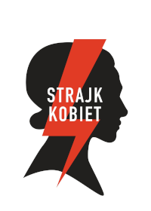
Ogólnopolski Strajk Kobiet
[Polish National Women's strike] Strike]

